Chapter 1, Problem 18.

Find the power absorbed by each of the elements in Fig. 1.29.

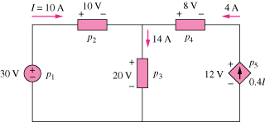

Figure 1.29
For Prob. 1.18

